Digital Fashion: Dress Design Using Python
Xiaoran Huang

Abstract: This project combines Python's Turtle graphics and AI-driven tools to create innovative fashion designs. A dress is designed using Python and then imported into the Canvas Editor, an AI platform, where it is rendered in various styles. This approach demonstrates how coding and AI can be integrated to produce unique and customizable fashion designs.
Significance: This project highlights the intersection of technology and fashion design, showcasing how programming can enhance creativity and streamline the design process. It emphasizes the role of AI in generating diverse styles, allowing for faster and more innovative fashion design development.
Results:
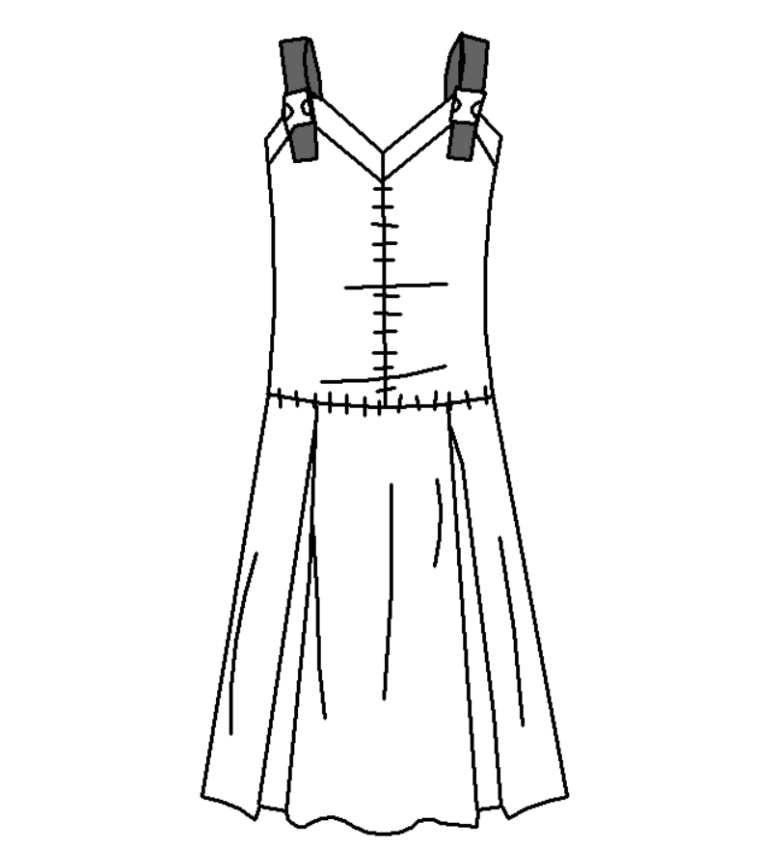
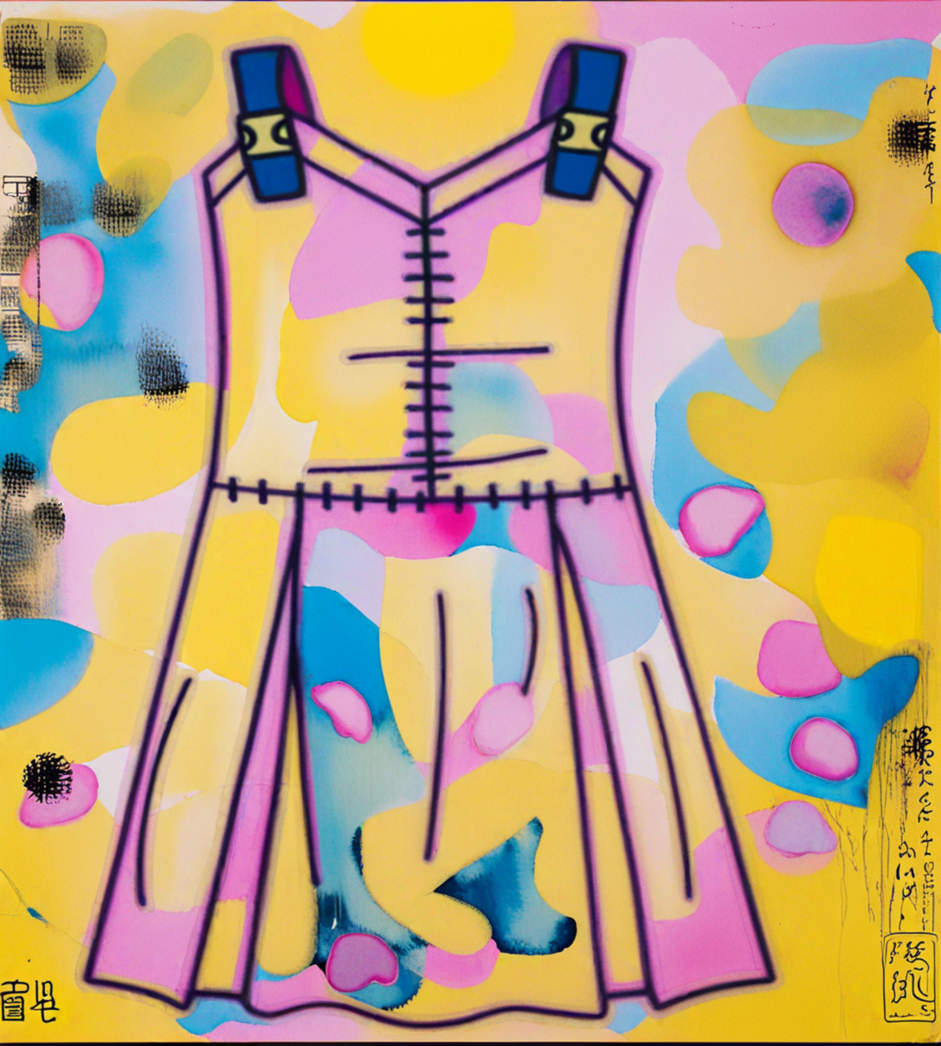

Fig 1. Dress plotted by turtle in python Fig 2. Dress plotted by Canvas based on Fig 1

Discussion: Due to technical limitations, 3D rendering and simulation features could not be incorporated in this project. This restricted the ability to visualize the dress in a more dynamic and realistic way. However, this project highlights the potential of combining technology and fashion design. In future studies at HKUST, I hope to learn advanced techniques like 3D modeling and garment simulation, which will further enhance my design capabilities and provide deeper insights into the practical aspects of sustainable fashion.

